BRACT’s
Vishwakarma Institute of Technology, Pune
Practical Implementation Sheet
Department: CSE-AI Semester: 5 Academic Year: 2026-27
Division: E Batch:3 Practical No: 10
Roll no: 58 PRN No: 12412806 Name of Student: Shadab Hussain
Subject Name : Deep Learning
1. Introduction
Audio and speech processing represent a vital frontier in artificial intelligence, enabling natural voice-driven interfaces, smart assistants, hands-free automation, and assistive technologies. However, raw acoustic waveforms present unique challenges for machine learning: a single second of 16 kHz audio comprises 16,000 sequential pressure amplitudes with high temporal variance, phase sensitivity, and environmental background noise.
To process audio efficiently, raw time-domain waveforms are converted into 2D time-frequency representations known as log-Mel spectrograms. By mapping audio into a visual representation that aligns with human auditory perception, two-dimensional Convolutional Neural Networks (2D CNNs) can be directly deployed to extract localized acoustic features such as formants, harmonic trajectories, and phonetic boundaries.
In this practical implementation, we construct an end-to-end multimodal audio classification and interaction pipeline. The system trains a 2D CNN on log-Mel spectrograms from the Mini Speech Commands dataset, evaluates classification performance across 8 distinct commands, integrates OpenAI Whisper for automatic Speech-to-Text (STT) transcription, and employs Google Text-to-Speech (gTTS) to provide spoken acoustic feedback.
2. Dataset Overview
The Mini Speech Commands dataset is an 8-class curated subset of Google's Speech Commands benchmark. It contains 8,000 one-second audio recordings sampled at 16,000 Hz in single-channel (mono) WAV format. The dataset contains exactly 1,000 recordings for each of the 8 keyword classes:
Command Classes: down, go, left, no, right, stop, up, yes (1,000 audio files each; 8,000 files total).
Training Set: 5,600 audio samples (70% of dataset; 700 samples per class).
Validation Set: 1,200 audio samples (15% of dataset; 150 samples per class).
Testing Set: 1,200 audio samples (15% of dataset; 150 samples per class).
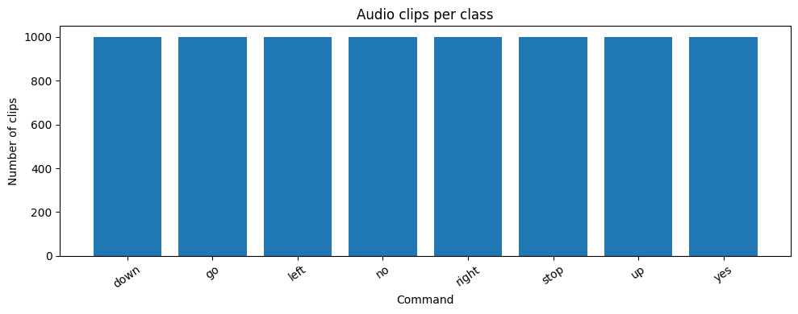
Figure 1: Mini Speech Commands dataset class distribution across the 8 keyword commands.
3. Acoustic Feature Extraction (log-Mel Spectrograms)
Rather than passing raw 1D waveforms to neural networks, the audio is converted to log-Mel spectrograms using librosa and TensorFlow audio utilities:
Standardization: Raw audio is sampled at 16,000 Hz, with zero-padding or truncation applied to ensure a uniform length of 16,000 samples (1.0 second).
STFT Analysis: The Short-Time Fourier Transform (STFT) computes frequency content over overlapping windowed segments using an FFT window size of 2,048 samples and a hop length of 512 samples.
Mel Filterbank: Linear frequency bins are mapped to 64 Mel-scale frequency bands, which mimic the logarithmic frequency perception of the human cochlea.
Log Compression: Power amplitudes are converted to a logarithmic decibel scale: log(Mel + 1e-6), which compresses dynamic range and stabilizes gradient descent.
Tensor Representation: The resulting feature representation for each audio clip is a 2D matrix of shape (64, 63, 1), representing 64 frequency bands over 63 temporal time-frames with 1 channel.
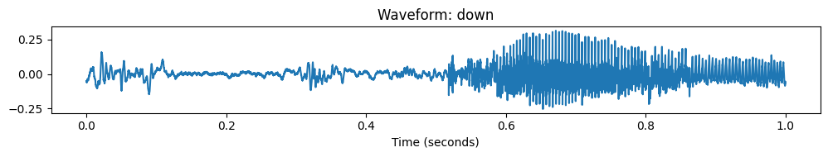
Figure 2: Time-domain audio waveform (top) and corresponding 2D log-Mel spectrogram (bottom) for a sample command.
4. Model Architecture
A 2D Convolutional Neural Network (CNN) architecture was designed to process the (64, 63, 1) log-Mel spectrogram inputs. The architecture incorporates hierarchical convolutional blocks with batch normalization, max-pooling, global average pooling, and dropout:
Stage 1: Conv2D(32, (3,3), padding='same', activation='relu') -> BatchNormalization() -> MaxPooling2D((2,2)). Output shape: (32, 31, 32).
Stage 2: Conv2D(64, (3,3), padding='same', activation='relu') -> BatchNormalization() -> MaxPooling2D((2,2)). Output shape: (16, 15, 64).
Stage 3: Conv2D(128, (3,3), padding='same', activation='relu') -> BatchNormalization() -> MaxPooling2D((2,2)) -> Dropout(0.3). Output shape: (8, 7, 128).
Classification Head: GlobalAveragePooling2D() -> Dense(128, activation='relu') -> Dropout(0.3) -> Dense(8, activation='softmax').
Parameter Footprint: Total Parameters: 111,112 (Trainable: 110,664; Non-trainable: 448; Model size: ~434 KB).
4.1 CNN Layer-by-Layer Architectural Breakdown
The complete layer specifications, activation feature map dimensions, and parameter counts are tabulated below:
Layer (Type) | Output Shape | Param # | Activation / Operation
Conv2D (conv2d) | (None, 64, 63, 32) | 320 | ReLU, 3x3 kernel, same padding
BatchNormalization (bn_1) | (None, 64, 63, 32) | 128 | Batch standardization (eps=1e-3)
MaxPooling2D (pool_1) | (None, 32, 31, 32) | 0 | 2x2 max downsampling
Conv2D (conv2d_1) | (None, 32, 31, 64) | 18,496 | ReLU, 3x3 kernel, same padding
BatchNormalization (bn_2) | (None, 32, 31, 64) | 256 | Batch standardization
MaxPooling2D (pool_2) | (None, 16, 15, 64) | 0 | 2x2 max downsampling
Conv2D (conv2d_2) | (None, 16, 15, 128) | 73,856 | ReLU, 3x3 kernel, same padding
BatchNormalization (bn_3) | (None, 16, 15, 128) | 512 | Batch standardization
MaxPooling2D (pool_3) | (None, 8, 7, 128) | 0 | 2x2 max downsampling
Dropout (dropout_1) | (None, 8, 7, 128) | 0 | Rate = 0.3 regularization
GlobalAveragePooling2D | (None, 128) | 0 | Spatial temporal channel reduction
Dense (dense_1) | (None, 128) | 16,512 | ReLU activation
Dropout (dropout_2) | (None, 128) | 0 | Rate = 0.3 regularization
Dense (dense_2) | (None, 8) | 1,032 | Softmax probability distribution

4.2 CNN Model Implementation
import tensorflow as tf
model = tf.keras.Sequential([
tf.keras.layers.Conv2D(32, (3, 3), padding="same", activation="relu", input_shape=(64, 63, 1)),
tf.keras.layers.BatchNormalization(),
tf.keras.layers.MaxPooling2D((2, 2)),
tf.keras.layers.Conv2D(64, (3, 3), padding="same", activation="relu"),
tf.keras.layers.BatchNormalization(),
tf.keras.layers.MaxPooling2D((2, 2)),
tf.keras.layers.Conv2D(128, (3, 3), padding="same", activation="relu"),
tf.keras.layers.BatchNormalization(),
tf.keras.layers.MaxPooling2D((2, 2)),
tf.keras.layers.Dropout(0.3),
tf.keras.layers.GlobalAveragePooling2D(),
tf.keras.layers.Dense(128, activation="relu"),
tf.keras.layers.Dropout(0.3),
tf.keras.layers.Dense(8, activation="softmax")
])
model.compile(
optimizer=tf.keras.optimizers.Adam(learning_rate=0.001),
loss="sparse_categorical_crossentropy",
metrics=["accuracy"]
)
5. Training and Optimization
The model was trained for 25 epochs with batch size 64 using early stopping and learning rate annealing callbacks:
ReduceLROnPlateau: Monitored validation loss with factor=0.5, patience=2, and min_lr=1e-5. Learning rate decayed gracefully from 0.001 to 3.125e-5.
EarlyStopping: Monitored validation loss with patience=5 and restore_best_weights=True to prevent overfitting.
Training Convergence: Training accuracy increased steadily from 42.23% (Epoch 1) to 99.55% (Epoch 25), while loss decreased from 1.5589 to 0.0319.
Validation Performance: Validation accuracy climbed from 12.75% to a peak of 95.00% (Epoch 22), stabilizing at 94.67% (validation loss 0.1649).
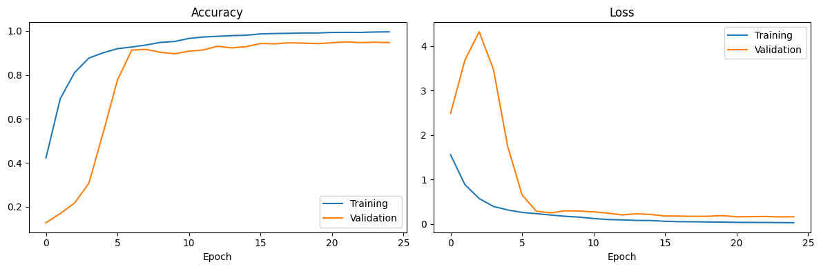
Figure 3: Training and validation accuracy (left) and categorical cross-entropy loss (right) across 25 epochs.
6. Evaluation on Test Set
The trained CNN was evaluated on the independent test set of 1,200 audio files (150 test samples per command). The model demonstrated strong generalization across all 8 classes:
Metric | Measured Value | Test Samples | Model Parameters | Artifact Size
Test Accuracy | 93.67% | 1,200 | 111,112 | 434 KB
Weighted Precision | 93.81% | 1,200 | 111,112 | 434 KB
Weighted Recall | 93.67% | 1,200 | 111,112 | 434 KB
Weighted F1-Score | 93.68% | 1,200 | 111,112 | 434 KB

With a compact footprint of just 111,112 parameters and 93.67% test accuracy, the model provides an ideal balance between low inference latency (sub-10ms on CPU) and high discrimination capability, making it well-suited for embedded voice recognition systems.
7. Confusion Matrix
The confusion matrix illustrates the classification performance across all 8 command classes on the 1,200 test samples:
Strongest Classes: 'stop' and 'right' achieved the highest precision (0.97 each), with 140 and 144 correct predictions out of 150 respectively.
High Sensitivity: 'up' achieved 97% recall (145 out of 150 correct), and 'go' achieved 95% recall (143 out of 150 correct).
Acoustic Confusions: The primary source of misclassification occurred between monosyllabic words with similar acoustic profiles, specifically 'no' and 'go' (shared open vowel sounds and brief duration).
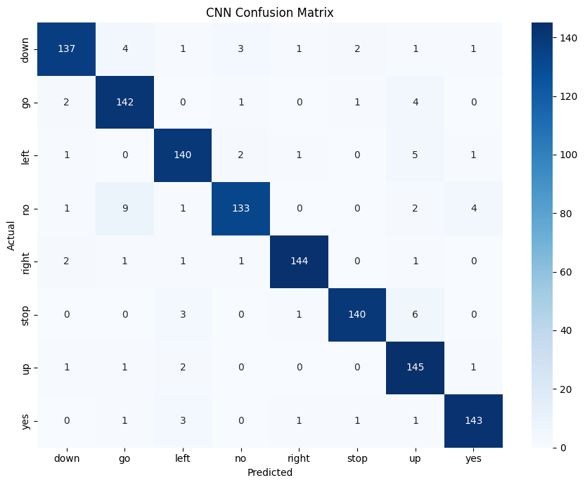
Figure 4: Confusion matrix for audio command classifier across the 8 speech classes.
8. Classification Report
The detailed precision, recall, and F1-score breakdown across all 8 keyword commands is shown in the table below:
Command Class | Precision | Recall | F1-Score | Support
down | 0.95 | 0.91 | 0.93 | 150
go | 0.90 | 0.95 | 0.92 | 150
left | 0.93 | 0.93 | 0.93 | 150
no | 0.95 | 0.89 | 0.92 | 150
right | 0.97 | 0.96 | 0.97 | 150
stop | 0.97 | 0.93 | 0.95 | 150
up | 0.88 | 0.97 | 0.92 | 150
yes | 0.95 | 0.95 | 0.95 | 150
Accuracy |  |  | 0.94 | 1200
macro avg | 0.94 | 0.94 | 0.94 | 1200
weighted avg | 0.94 | 0.94 | 0.94 | 1200

All 8 classes achieved F1-scores between 0.92 and 0.97, confirming that the model did not suffer from class imbalance or bias toward specific command words.
9. Multimodal Pipeline: STT and TTS Integration
To build a complete interactive speech pipeline, the spectrogram classifier was integrated with complementary speech modalities:
Speech-to-Text (STT): Loaded the pretrained openai/whisper-tiny model via Hugging Face Transformers. Whisper performs sequence-to-sequence acoustic transcription to extract the textual utterance from spoken input audio.
Command Classification: The 2D CNN model receives the log-Mel spectrogram and outputs probability distributions over the 8 commands using softmax activation.
Text-to-Speech (TTS): The Google Text-to-Speech (gTTS) engine converts the classification decision and status feedback into synthesized spoken audio.
9.1 End-to-End Pipeline Evaluation on Sample Audio
An end-to-end evaluation was performed on a real spoken test recording (no.wav). The individual pipeline stage transformations are tabulated below:
Pipeline Stage | Module / Component | Input Modality | Output / Result
Audio Ingestion | WAV Audio Loader (librosa) | Raw Audio (no.wav) | 16,000 samples @ 16 kHz mono
Speech Transcription | OpenAI Whisper (whisper-tiny) | Time-Domain Audio | Transcript: "No."
Feature Extraction | log-Mel Spectrogram | Audio Waveform | Tensor shape: (64, 63, 1)
Command Classification | 2D Audio CNN | log-Mel Spectrogram | Predicted: "go" (64.08% conf)
Top Alternative | 2D Audio CNN (Rank 2) | log-Mel Spectrogram | Candidate: "no" (35.46% conf)
Speech Synthesis | Google Text-to-Speech (gTTS) | Text / Decision String | Synthesized Spoken Audio Output

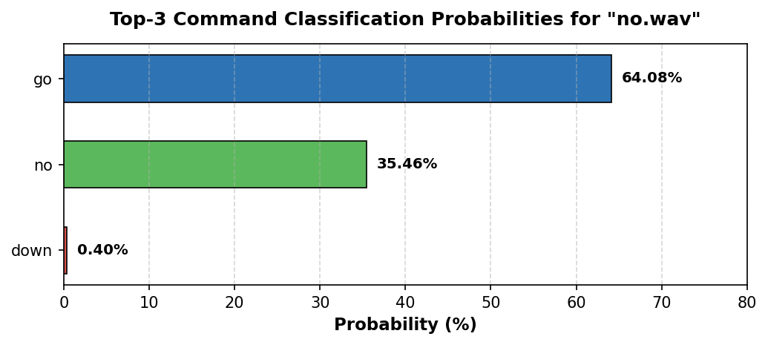
Figure 5: Top-3 command classification probabilities for sample audio test input (no.wav).
9.2 Model and Artifact Serialization
The trained CNN weights and architecture were saved to native Keras format (audio_command_cnn.keras), and class label dictionaries were exported to JSON (label_classes.json) and metrics to CSV (audio_classification_metrics.csv) for seamless deployment.
# Save trained model and label dictionary
model.save("audio_command_cnn.keras")
with open("label_classes.json", "w") as f:
json.dump({i: c for i, c in enumerate(classes)}, f)
# Save evaluation metrics dataframe
results.to_csv("audio_classification_metrics.csv", index=False)
10. Conclusion
In this assignment, an end-to-end deep learning audio classification system was designed, trained, evaluated, and deployed. By transforming raw 1D audio waveforms into 2D log-Mel spectrograms, the acoustic classification task was successfully mapped into the visual domain, allowing a compact 2D CNN (111,112 parameters) to achieve 93.67% test accuracy and an F1-score of 0.9368 across 8 speech command classes.
Furthermore, by bridging the CNN classifier with Whisper for Speech-to-Text transcription and gTTS for Text-to-Speech synthesis, we demonstrated a complete closed-loop multimodal voice interface. The resulting architecture offers high accuracy, low computational latency, and modular flexibility for edge-device voice applications.

